1. <https://github.com/sarahhiguchi/final206>
2. Goals of this project: Use two API’s, Songkick and Musixmatch, to compare different cities on what genres of music they listen to based on the upcoming concerts in the area as well as find lyrics to the top songs of whatever artist is coming to perform for the ultimate “Concert Study Guide”.
3. Goals we’ve achieved: We successfully used the two API’s but only managed to pull the genres and not the lyrics. We were able to find 20 events per city that was plugged into our program and pull the artists names from those events as well. Then we used those artists’ names to plug into the Musixmatch API to find what genre their music fell under.
4. The problems that you faced: There were a lot of issues surrounding pushing and pulling from github without compromising the others’ code. In addition we had issues figuring out how to use certain API’s that require more levels of authentication.
5. 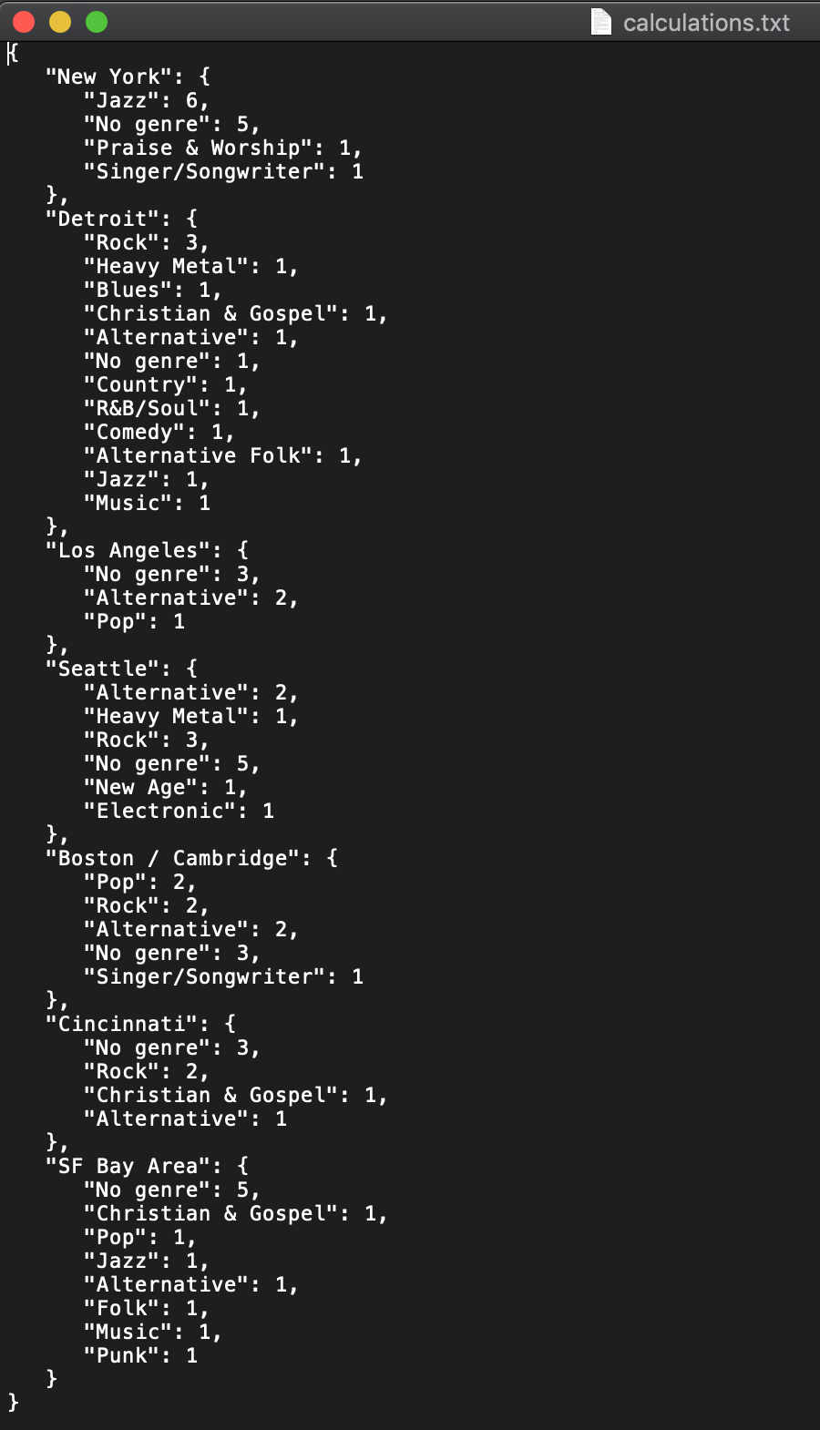
6. 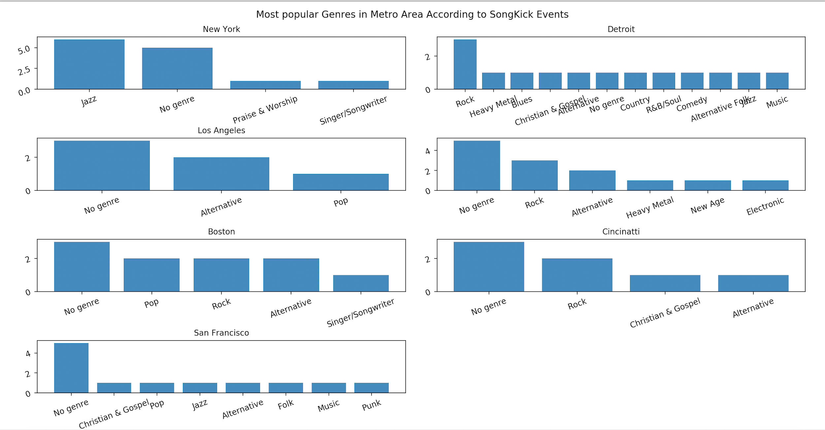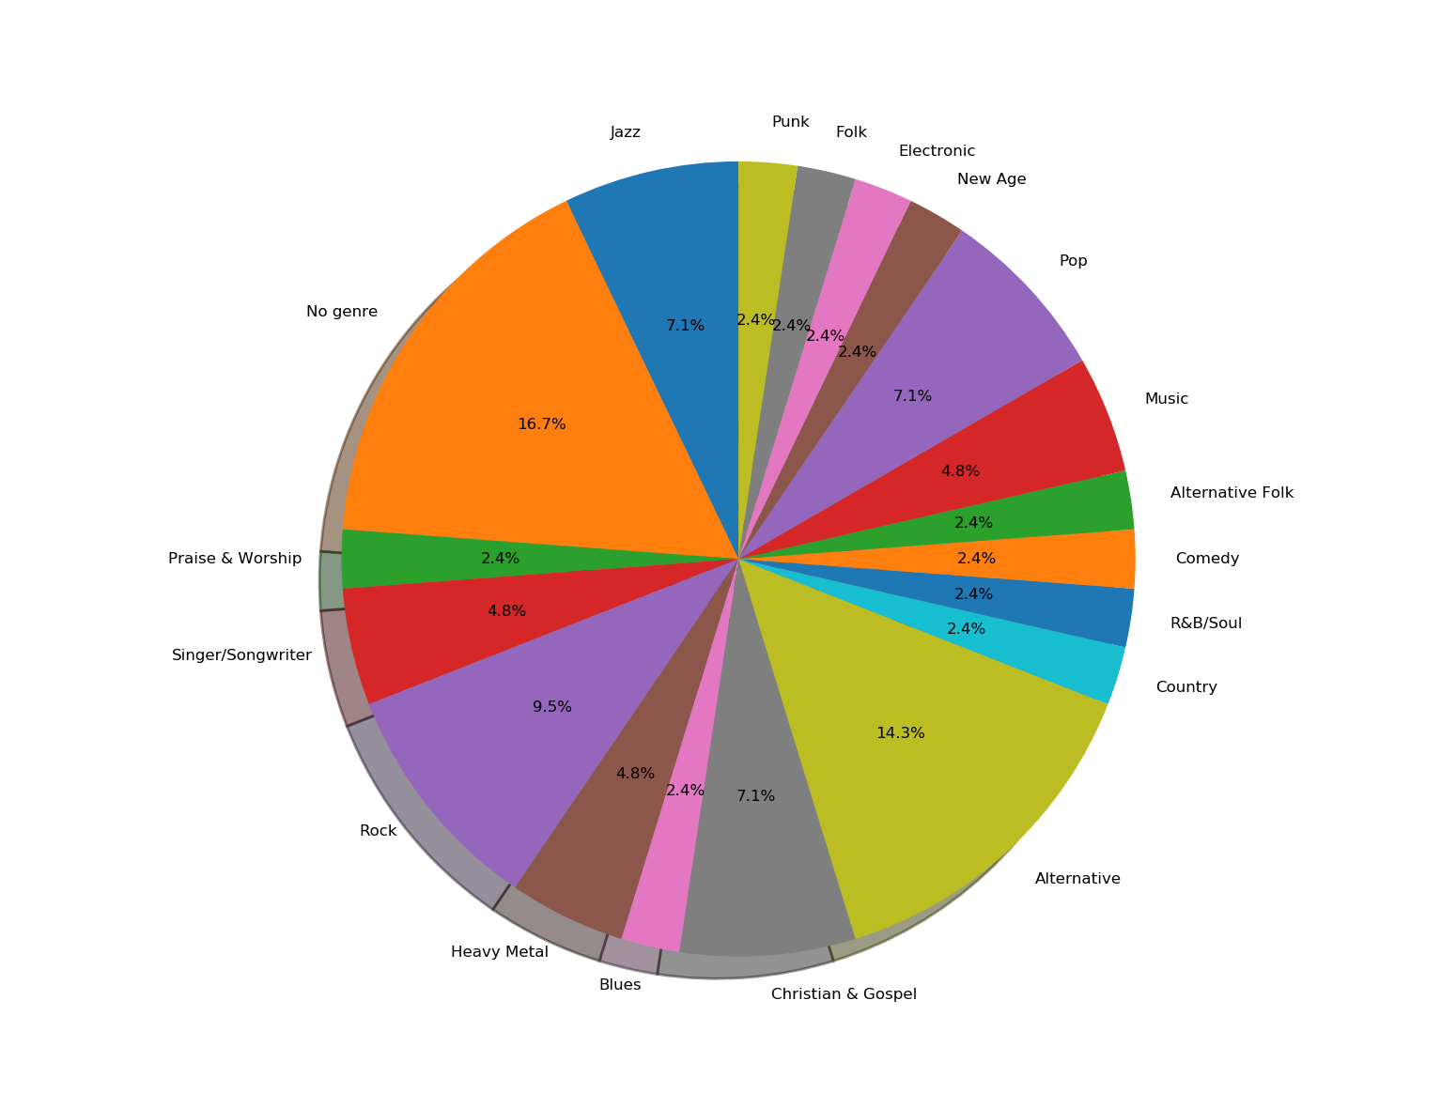
7. To run the code, put in the names of 7 big cities (preferably in America) in the list called locations. Currently we have it set up with 7 different cities. You can either change the cities, or just run the code to see our suggested cities
8. information from musixmatch about what genre their music falls under and then count the totals of each genre in relation to where the artist is playing.

|  |  |  |
| --- | --- | --- |
| Function | Input | Output |
| get_locid_songkick | Location name (string) | The location results from a request (dictionary) from the songkick API as well as the location ID(integer). (Tuple) |
| get_data_songkick | Metroarea ID number (integer) | Data pulled from songkick on the 20 events from each location (dictionary) and a list of artists that are performing at the events. |
| musixmatch_artist_search | Artist name (string) | Data pulled from musixmatch on artist information (dictionary), the artist ID (integer), artist rating (integer) |
| album_get | Artist ID (integer) | Data pulled from musixmatch on top album by the artist (dictionary), the genre associated with that album (string). |
| setUpSKlcdTable | Data for metroarea id in a python object | An sql table with city names, country, and metro area id |
| setUpSKlcdData | python object/dictionary of metro area id’s for the cities we put in earlier | An sql table of metro area id’s, event name, city name where event is happening, the head artist at the event, and metro area name |
| SetupMMsearchTable | Python object/dictionary of artist names that we got from | An sql table of artist names, the artist’s id, and the artist’s rating |
| setupGenreTable | Python object/dictionary of artist id’s | An sql table of artist names, and their genres based off of their album genres |
| get_category_dict | Takes in an sql filename, the file with all the tables we created | Returns a list of lists. Each list is for each metro area and in each metroarea list there are tuples with a genre and the number of times the genre occurs in the metro area (based on events) |
| write_to_file | Takes in a list containing lists that has tuples | Writes the calculations to a file |
| bar_chart | Takes in a list containing lists that has tuples | Creates a matlab bar chart of each metro area showing how many events are happening per genre is ascending order |
| get_percentages_genres | Takes in a list containing lists that has tuples | Returns a dictionary of percentages of each genre |
| make_pie | Takes in a dictionary with percentages | Makes a pie chart showing the percentages of each music genre’s for the metro area’s |
| Main | Lets us run our functions and put in the input it needs | Creates sql tables, calculations, and visalizations |

|  |  |  |  |
| --- | --- | --- | --- |
| Date | Issue Description | Location of resource | Result (did it solve the issue?) |
| 12/15/19 | I wanted to find know to to put axis labels for each subplot | <https://matplotlib.org/1.3.0/users/tight_layout_guide.html> | Yes it did help me |
| 12/10/19 | Program not running because we got locked out of api | <https://developer.musixmatch.com/buyer/stats#%7B%22dateRange%22:%7B%22period%22:%7B%22number%22:24,%22unit%22:%22hour%22%7D,%22granularity%22:%22hour%22%7D,%22selectedMetricName%22:%22hits%22,%22timezone%22:%22Etc/UTC%22,%22selectedApplicationId%22:%221409618781365%22%7D> | This helps me know the amount I’ve pulled from the API so it helped us know when to save our pulls |
| 11/15/16 | Wanted to know how to sort by value in a dictionary in a dictionary | <https://stackoverflow.com/questions/4110665/sort-nested-dictionary-by-value-and-remainder-by-another-value-in-python> | Nope did not help, but did remind of the lambda syntax |
| 12/17/19 | Pie Chart was not printing | <https://matplotlib.org/3.1.1/api/_as_gen/matplotlib.pyplot.pie.html> | It showed me the necessary parameters for the pie attribute |
| 12/15/19 | I wanted to know to sort a nested dictionary | <https://stackoverflow.com/questions/43752962/how-to-iterate-through-a-nested-dict/43753252> | Yes, taught me how to sort by key, value |
| 12/11/19 | Didn’t want to continuously request data to see requested results | <https://www.songkick.com/developer/upcoming-events-for-metro-area> | Yes, it showed me the documentation for the requested results and the specific dictionary keys and values |
| 12/11/19 | “ ” | <https://developer.musixmatch.com/documentation/api-reference/artist-search> | “ ” |
| 12/10/19 | Wanting to look at json object | <https://jsoneditoronline.org/> | Yes it made it clear to me |
| 12/14/19 | Needed to know how to add unique constraint | <https://stackoverflow.com/questions/36518628/sqlite3-integrityerror-unique-constraint-failed-when-inserting-a-value> | Showed me where to add the word unique and to add insert or ignore, yes helped! |
| 12/18/19 | My axis labels were running into each other | <https://stackoverflow.com/questions/31186019/rotate-tick-labels-in-subplot-pyplot-matplotlib-gridspec?rq=1> | Yes showed me how to tilt my subplot axis labels |
| 12/18/19 | My axis labels were running into each other | <https://stackoverflow.com/questions/19273040/rotating-axis-text-for-each-subplot> | No was not helpful did not work |